|  |  |
| --- | --- |
|  | **MATHEMATICS:SPECIALIST 3 & 4**  **SEMESTER 2 2019**  **TEST 4**  **Calculator Free** |
|  |  |

Reading Time: 2 minutes Time Allowed: 30 minutes

Total Marks: 26

Question 1 (4 marks)

The curve defined by $y=3\cos\left(\begin{matrix}πx \\ \overline{ 16 }\end{matrix}\right)$, where $0≤x≤4$, is shown below.

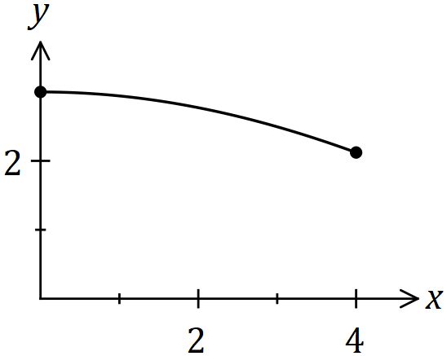

Determine the volume of the solid generated when the area bounded by the $x$ axis and the curve is rotated $360°$ about the $x$ axis between $x=0$ and $x=4$.

Question 2 (5 marks)

Part of the graph of $y=1+\begin{matrix}4 \\ \overline{x(x-5)}\end{matrix}$ is shown below.

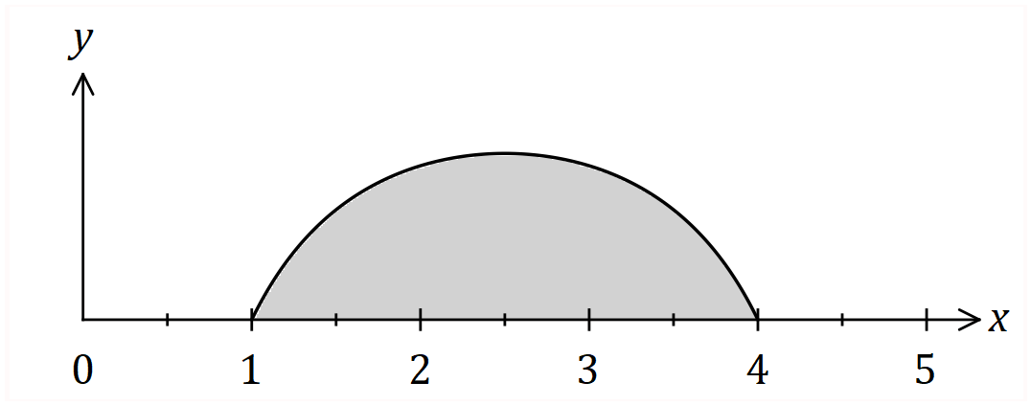

Determine the shaded area, bounded by the curve and the $x$-axis.

Question 3 (5 marks)

Use the substitution *u*  =  + 3 to find $\int{\frac{e^{2x}}{e^{x}+3}}$*dx.*

Question 4 (12 marks)

1. Use double-angle formulae to evaluate

 . (4 marks)

1. Use the substitution  to determine  . (4 marks)

1. Determine the value of the integer  if

$\int_{0}^{\frac{π}{2}}{sinx \cos^{n}xdx}=\frac{1}{2019}$ (4 marks)

|  |  |
| --- | --- |
|  | **MATHEMATICS:SPECIALIST 3 & 4**  **SEMESTER 2 2019**  **TEST 4**  **Calculator Assumed** |
|  |  |

Reading Time: 2 minutes Time Allowed: 26 minutes

Total Marks: 21

Question 5 (6 marks)

(a) An unknown function is such that its table of values are given below.

|  |  |  |  |  |  |  |  |  |  |  |  |
| --- | --- | --- | --- | --- | --- | --- | --- | --- | --- | --- | --- |
| x | 3 | 4 | 5 | 6 | 7 | 8 | 9 | 10 | 11 | 12 | 13 |
| f(x) | 13 | 13.8 | 14.1 | 14.6 | 15.3 | 15.7 | 15.9 | 16.5 | 17.1 | 18.6 | 20.1 |

Using the midpoint rule with 5 strips, determine the approximate area under the function between x = 3 and x = 13.

The formula for the midpoint rule is: $$\text{A} \text{≈} \text{w} \text{×} \sum_{\text{i=1}}^{\text{n}}{\text{f(}{\text{a}}_{\text{i}}\text{)}}$$

(3 marks)

(b) An unknown function is such that its table of values are given below.

|  |  |  |  |  |  |  |  |  |  |
| --- | --- | --- | --- | --- | --- | --- | --- | --- | --- |
| x | 1 | 1.5 | 2 | 2.5 | 3 | … | 10 | 10.5 | 11 |
| f(x) | 8.2 | 8.175 | 7.6 | 6.625 | 5.4 | … | 46 | 59.025 | 74.2 |

The formula for the trapezoidal rule is:

$$\text{A ≈ }\frac{\text{w}}{\text{2}}\text{ × }\left[\text{f}\left({\text{a}}_{\text{0}}\right)\text{ + 2}\sum_{\text{i=1}}^{\text{n-1}}{\text{f(}{\text{a}}_{\text{i}}\text{)}}\text{ + f(}{\text{a}}_{\text{n}}\text{)}\right]$$

Given that $\sum{\left(\text{8.2 + 8.175 + 7.6 + … + 74.2}\right)\text{ = 333.2}}$ determine the approximate area under the function between x = 1 and x = 11 using the trapezoidal rule.

(3 marks)

Question 6 (6 marks)

The region trapped between the curve y = (x – 1)3 + 2 and the line y = 3x + 1 is rotated about the y-axis. Determine the volume of the shape created.



**Question 7 (4 marks)**

Use partial fractions to prove that



Question 8 (5 marks)

The region $R$ enclosed by the curves $y^{2}=kx$ and $x^{2}=27ky$, has an area of $1156$ square units.

Determine the value of the positive constant $k$.